**A Project Report On**

**“World Explorer”**

**Index**

* 1. Introduction
  2. Hardware Requirement
  3. Software Requirement
  4. Synopsis
  5. Requirements
  6. Features
  7. UML Diagram
  8. Use Case Diagram
  9. Code Coverage
     1. Code Coverage for Eureka Server
     2. Code Coverage for API Gateway
     3. Code Coverage for JWT
     4. Code Coverage for User Details

**1.1 Introduction**

The World Explorer system provide the information about the different places. Basically the system provides the list of different pincode, cities and famous places.

The destination cities can also be search using the pin code. Pin code is the primary key for the database. With the help of pin code user can easily search their destination place according to the requirements.

System will provide different services for admin as well as user. Admin having authority to add the new places, delete the particular place, update the existing place and having access to get the list of all places. System will provide different exception handlers. In user side there will be a prove the service called getAllplace to fetch the list of all the places or depend on the search results.

* 1. **Hardware Requirement**

Processor: - 1.2GHz and above

Hard Disk: - 10GB and more

RAM: - Minimum 1 GB

**1.3 Software Requirement**

Operating System: - windows 10

Software’s: - STS, Mongo Shell, Git bash, Postman, Chrome, JDK 11, Mockito, Junit

* 1. **Synopsis:**

The World Explorer will be helpful for users. It gives the information about all the countries, cities in whole world in just one click. User can search whole the details according to their choices.

It providing Services like,

-Eureka Service

-API Gateway

1. Admin:

- Login

- Add Place

- Update Place

- Delete Place

2. User:

- Registration

- Login

- Famous Places

- Search Places

The Admin need to log-in into server to perform CRUD operation into Database. The user of this system should first register for any interaction with the system. Once registered, he/she will be provided with a username and password for the user to log in. If the login details are wrong it will throw exceptions and redirect user again to login server.

* 1. **Requirements:**

1. Famous Places

User can view for the famous places according to their destination.

1. Search Destination

While searching the location it will provide the exact location.

* 1. **Features:**

1. After searching for the particular place it will provide the whole list of places according to the user requirements.
2. User can access all the details of places according to their pin code which is unique for each places.
   1. **UML Diagram:**

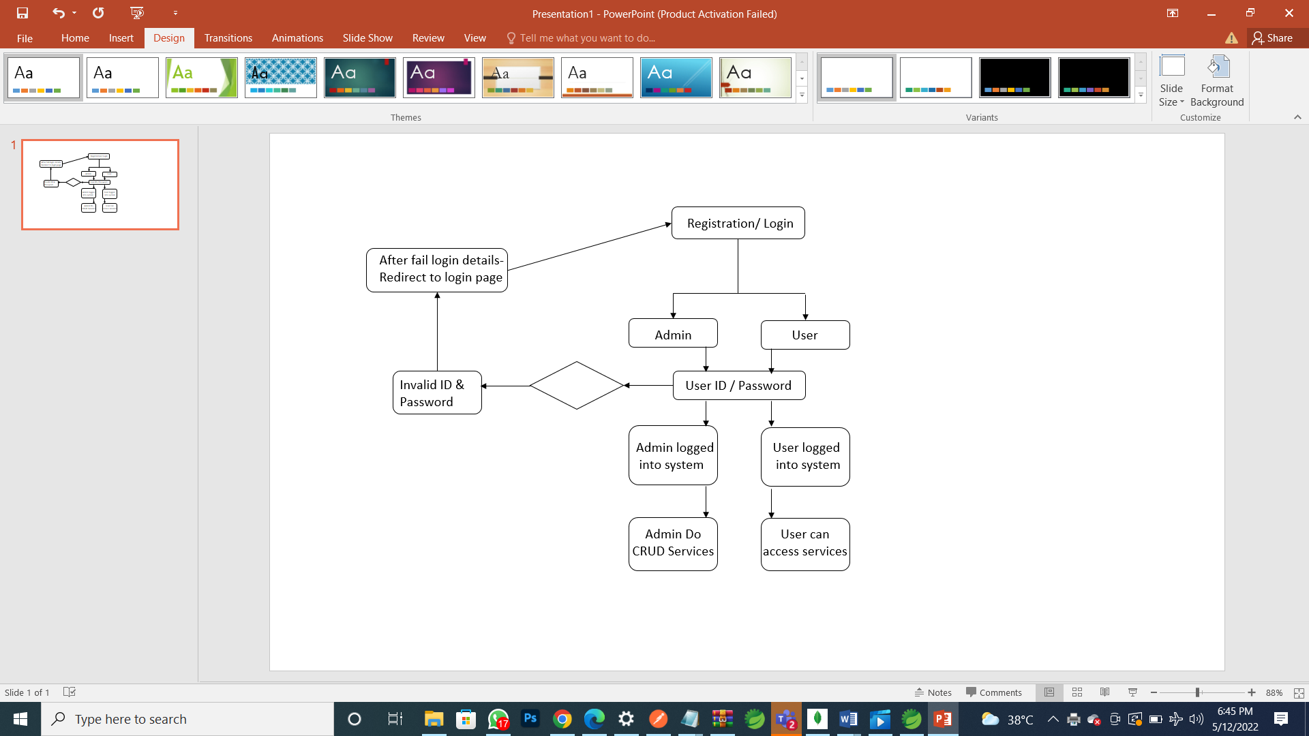

1.8 Use case Diagram:

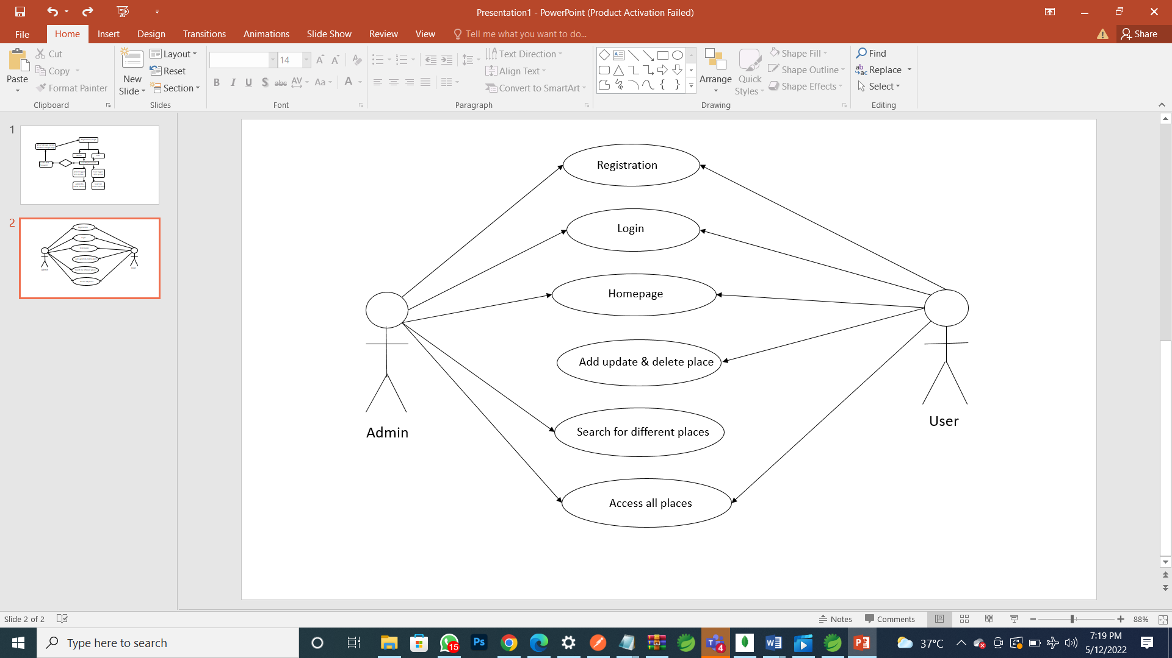

1.9 Code Coverage

1.9.1Code Coverage for Eureka Server:

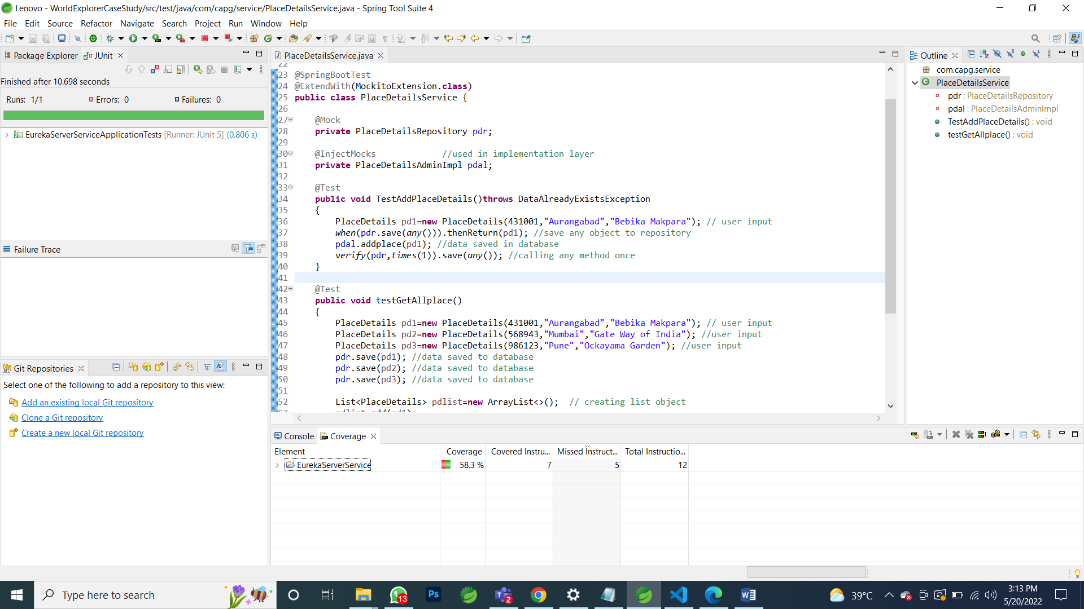

1.9.2 Code Coverage for API Gateway:

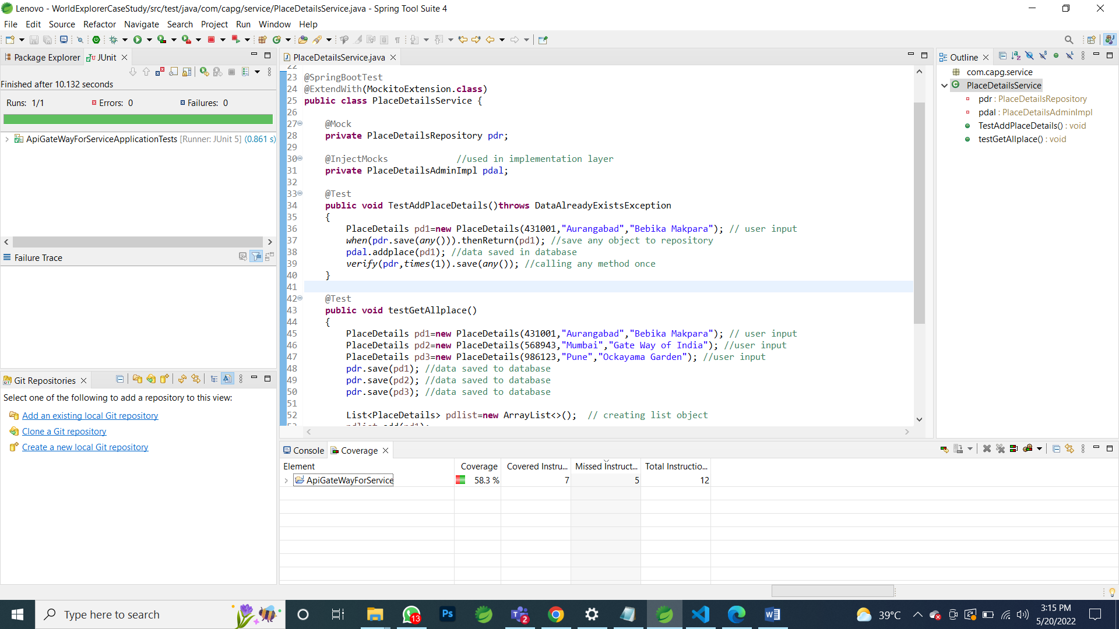

1.9.3 Code Coverage for JWT:

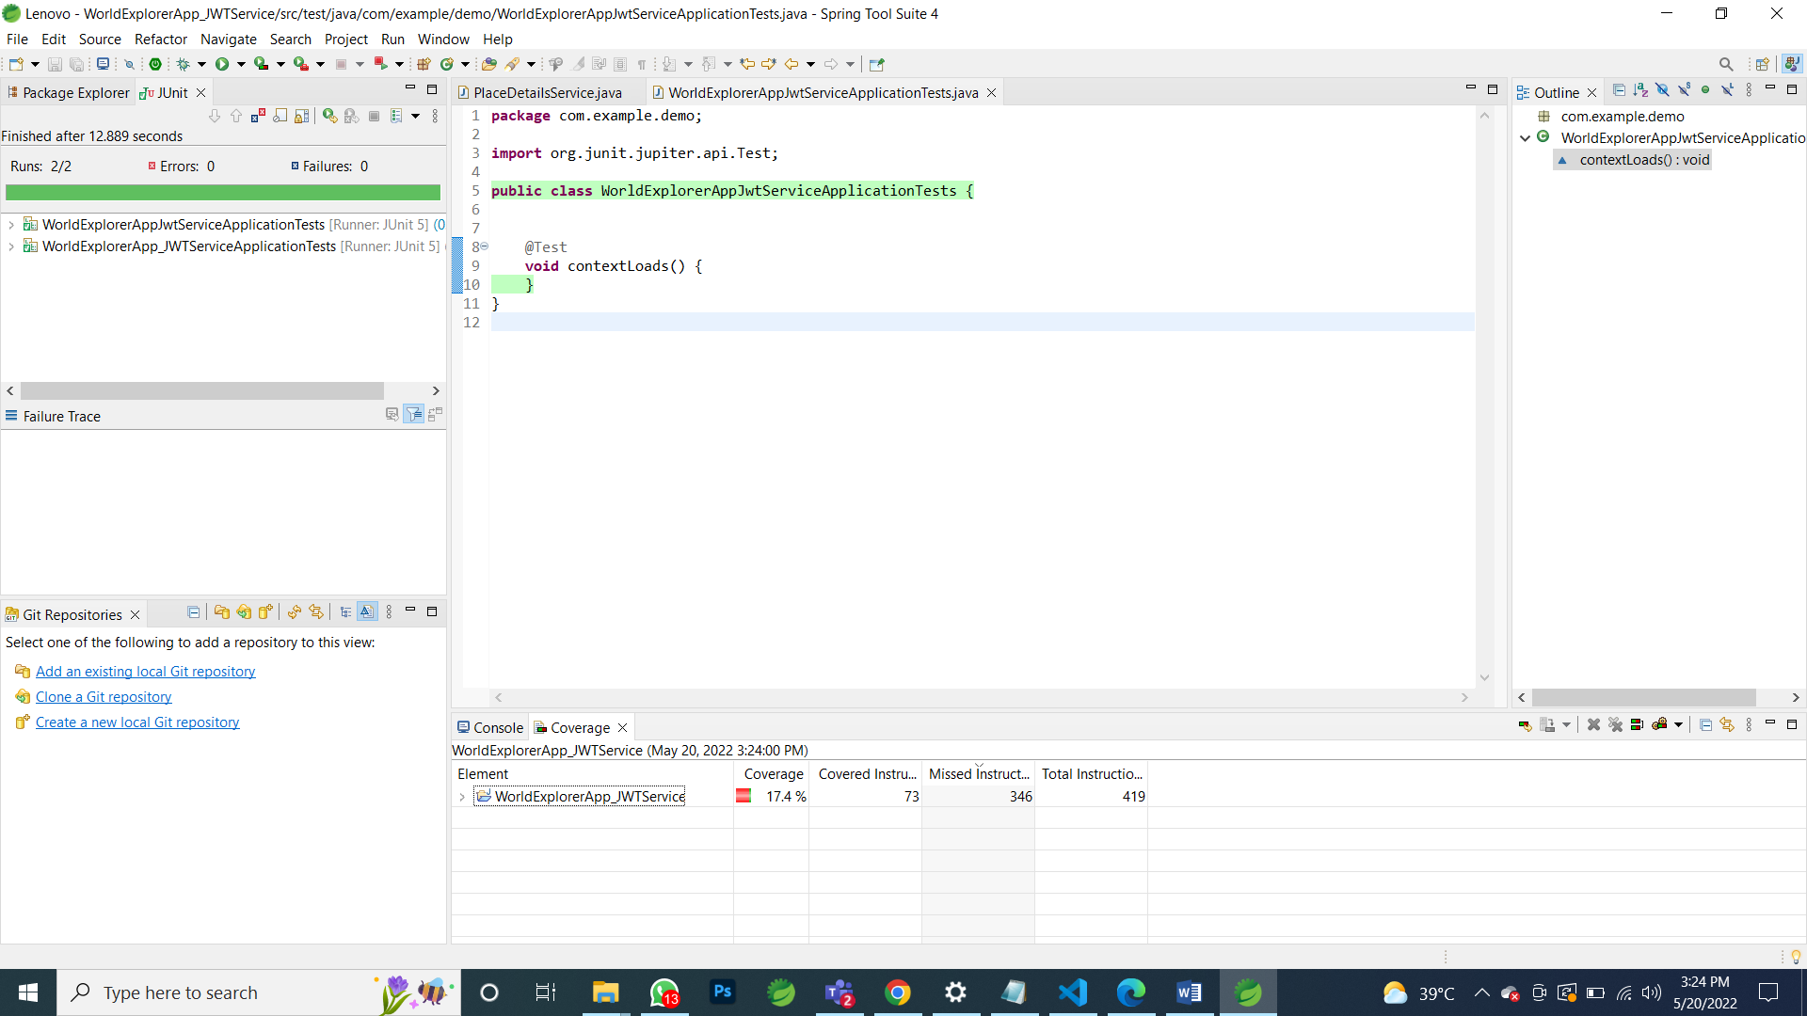

1.9.4 Code Coverage for User Details:

